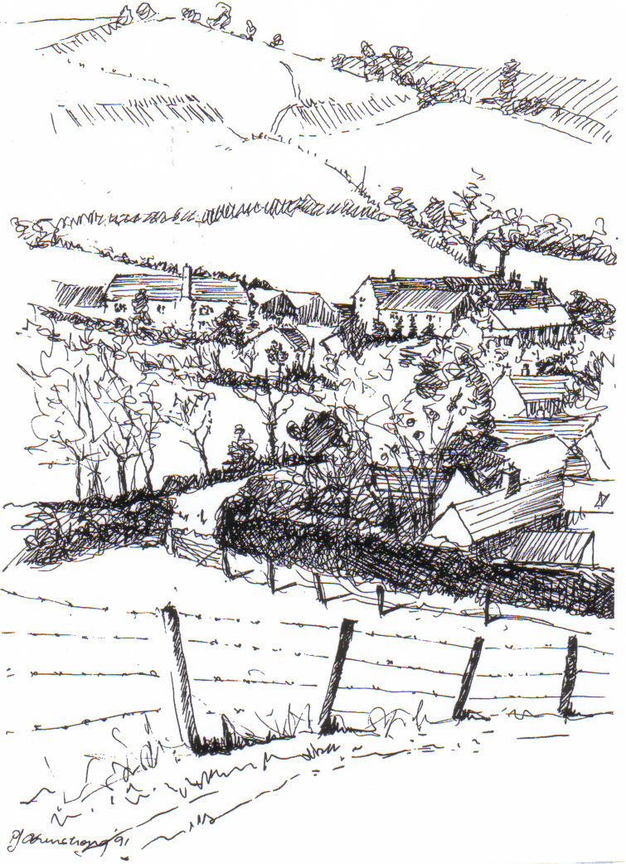
PARISH NEWS
The Deverills & Crockerton

Look inside for local information

Kingston Deverill from Court Hill by Pat Armstrong
May 2010
Look inside for local information
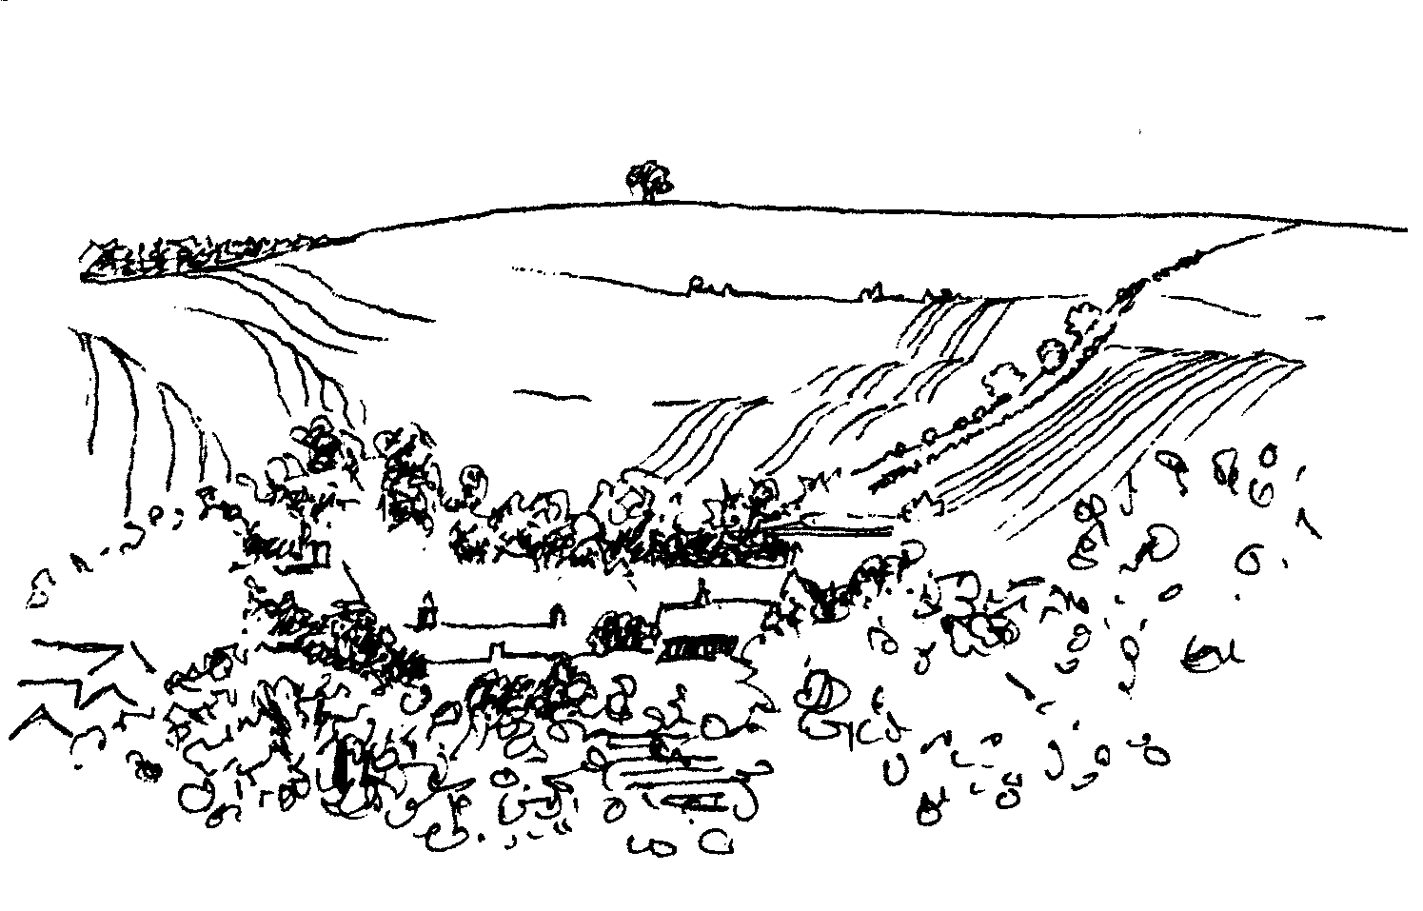
-2-

Sunday 9th May 10.30 am - 12.15 pm Sutton Veny Hall
Free Fun Singing Workshop
‘Sing Aloud’ lead by Claire Johnson
Children of all ages - songs & games
Call Claire on 01373 836012 or 079 6760 9520

Salisbury Theatre Club Trips
Monday 17th May
Les Liaisons Dangereuses
by Christopher Hampton
The cost is £17.00: theatre seat £12.00 and coach trip £5.00
Please book early to ensure tickets, payment in advance to Mary Stewart Cox
Tel 840877 at Longmead, Brixton Deverill, Warminster BA12 7EJ
Coach leaves Kingston Church 6.10 pm and collects through the Deverills
Performances begin at 7.30 pm

Coffee, Cards and Chat
Come and enjoy looking at the new range of cards,
ribbons, wrapping paper, and other exciting items
displayed by John and Maddie Goodden
in the Upper Deverills Village Hall on Thursday 19th February
between 10.30 and 12.00 noon - everyone is welcome
Donations will be made to the hall and the church

An invitation to another SCRABBLE TEA
Friendly fun afternoon for anyone, beginners or addicts!
Draw for partners at 2.00 pm on Wednesday 2nd June
Longbridge Deverill Village Hall
Admission £3.00 for 2 games, prizes, raffle, afternoon tea
Please call Ruth (212415 ) or Jill (840209)
by the end of May if you are coming
The surplus monies from this event are for the
Wilts Air Ambulance

Parish Lunch
In a Marquee on the Cricket Field at Kingston Deverill
Sunday 11th July
12.30 pm for 1.00 pm
Please bring your own drinks & glasses
Adults £10.00, Children £5.00
Proceeds will go to Church Funds
Tickets: Sylvia Titt 214825 or Janet Budgen 218203
Parish Lunch
In a Marquee on the Cricket Field at Kingston Deverill
Sunday 11th July
12.30 pm for 1.00 pm
Please bring your own drinks & glasses
Adults £10.00, Children £5.00
Proceeds will go to Church Funds
Tickets: Sylvia Titt 214825 or Janet Budgen 218203

Parish Lunch
In a Marquee on the Cricket Field at Kingston Deverill
Sunday 11th July
12:30 pm for 1:00 pm
Please bring your own drinks & glasses
Adults £10.00, Children£5.00
Proceeds will go to Church funds
Tickets: Sylvia Titt 214825 or Janet Budgen 218201

-3-
The Rector writes: Election ~ Fever or Frustration!
Through this Easter season thus far, we have been bombarded with election matters, on radio, on television and in our newspapers. Doubtless we all react differently to the way the General Election dominates the media. Sometimes it is easy to get caught up in the mood of the moment, while on other occasions, there is a real need to escape the subject and engage with other matters. One topic reported has been the number of people who choose not to vote. For various reasons they feel disillusioned with the political process and no longer think their vote can make a difference. When consideration is given to the lengthy fight that took place to secure a vote for each person, I feel it is regrettable that the situation has come to that. Using our vote surely enables (and maybe entitles) us to hold politicians to account. It reminds us of our corporate responsibility in the formation of society and in the maintenance of democracy. Whatever your political persuasion, do vote on 6th May!
Speaking of elections, last month saw elections in our churches, at our Annual Parochial Church Meeting. The results of those elections are posted on church notice boards. I would like to express my thanks to all who take on roles which contribute to the life of the parishes. I express my gratitude particularly to the churchwardens Elisabeth Atkinson, Mary Stewart Cox, Mike Tulloch and Tim Moore, and also to other elected officers and PCC members for all they do to promote the work and welfare of the churches in the Parish of the Deverills and Horningsham.
So by the time you read this, the General Election will be upon us! Whether you respond with election fever or frustration, I hope that you will vote on the day.
In the meantime, continuing Easter blessings.
Norma Payne
Coffee Morning in aid of Christian Aid
The Rectory on Friday 14th May from 10.00 am - 12.00 noon
Bring and Buy stall, Raffle
Please support this event - as there will be no house to house collection

Christian Aid Week 9th - 15th May
This is seven days of fundraising, action and prayer. A time when communities all over the country get together to raise funds to make real and lasting changes in the lives of some of the world’s poorest people. The week started as churches’ responded to the horrors of the refugee crisis in Europe after the Second World War. Different churches in the UK and Ireland started fundraising – sending the money through partner organisations best placed to make a difference on the ground. The CA envelopes are delivered by volunteers, to over 10 million homes, raising about £9 million each year – nearly £1 million in Gift Aid alone. This year we hope to raise over £14 million - to effect massive change. Christian Aid supporters hold thousands of events - coffee mornings, plant sales, book sales, sponsored walks, talent competitions etc. 22,000 churches, schools, workplaces and individuals work together making the week a great success. For more information see www2.christianaid.org.uk

-4-
Annual Parochial Church Meeting
The Deverills & Horningsham
The APCM was held at Longbridge Deverill Village Hall on the 11th April, in order to hold elections for offices in 2010/2011, give the annual report and present the church accounts. Chaired by our Rector, Rev Norma Payne, and attended by 27 parishioners the meeting re-elected our long-standing Church Wardens but we need new faces at Longbridge and Brixton next year. Elisabeth and Mary continue to do a wonderful job, as Church Wardens, but they need a break. Mary Royall and Jo Steptoe retired from the PCC as they had completed their 3 years on the Council and were thanked for all their efforts over the years. Other positions were filled by the previous incumbents, see the back page for details. The Treasurer summed up the church finances by drawing attention to the fact that the church’s income, derived solely from the congregation’s contributions, is not increasing in line with expenditure. This situation is compounded by the much reduced interest rates now available and the inevitable rise in the cost of everything.
The Rector, in her review, pointed out the success of our service pattern and the pleasure at seeing so many attending the major festivals in our churches. The choir started by Claire Johnson has gone from strength to strength and their success has been matched by the Bell Ringers at Longbridge Deverill; long may both continue. Challenges remain in attracting new members to our churches and how we may expand our Christian knowledge by study and shared learning. The Annual Report, the election results and minutes of the APCM will be on display on all our churches notice boards.
Nigel Poole - PCC Secretary
Community Emergency Volunteer Position
I wish to say thank you to Caroline Sawyer for responding to my request for a replacement Community Emergency Volunteer. Caroline is very suited to the position as she is an experienced Health and Safety Technician. She has been in touch with Wiltshire Council and they are pleased to accept her as the CEV for the Upper Deverills. I know everyone will be supportive, when and if a community emergency does occur.
The contact list of people who can be called upon to assist in a community emergency does need some updating. With this in mind Caroline may be in touch with those people already on the list and may possibly be looking for more contacts to add to it.
Thank you all for your support in the past.
Carole Noonan

-5-
Upper Deverills Parish Council
The Annual Parish Meeting will take place on Wednesday 12th May at 6.30 pm in Upper Deverills Village Hall, to be followed by the Annual Council Meeting. Everyone is very welcome to attend; we look forward to seeing you.
Longbridge Deverill and Crockerton Parish Council
Speed watch now active in Crockerton
Crockerton now has volunteers for the community speed watch. They have been out at different times of the day and have monitored the speed of traffic along Clay Street. Going out as early as 7.30 am in the morning and at lunchtimes and in the evenings. Motorists who are speeding have their speed and registration number recorded and this information is then sent to the police who send out a letter to the offender. If you would like to become one of the volunteers please contact Helen Few, clerk of the parish council, by email: hkfew@hotmail.com for more information. Make our village a safer place with community speed watch.
Please do not forget that anyone is welcome to attend the Parish Council meetings, a short comment can always be made at the start of proceedings. The next meeting will be on Tuesday 4th May, 7.30 at Longbridge Village Hall.
Helen Few - Clerk 840119
General Election - Thursday 6th May
Wiltshire Council has the responsibility to run the election to select the MPs who will represent Wiltshire at Westminster. You should have registered to vote by the 20th April.
Wiltshire has five constituencies: Chippenham, North Wiltshire, Devizes, Salisbury, and South West Wiltshire. Polling stations across the county will be open from 7.00 am to 10.00 pm. Details of local polling stations will be included on polling cards which will be sent to everyone eligible to vote.
Some of the boundaries have changed and some people will now be in a different constituency. For the first time there is a new Chippenham constituency. You can view each of the areas on the website at www.wiltshire.gov.uk/council/elections and find your constituency and local polling station with the electoral constituency finder.
Votes will be counted after the polling stations have closed and the results will be announced in the early hours of the morning of 7th May.
Counting will take place at five venues:
Salisbury - City Hall, Salisbury.
Chippenham - Olympiad Leisure Centre, Chippenham.
Devizes - The Corn Exchange, Devizes.
South West Wiltshire - The Civic Hall, Trowbridge.
North Wiltshire - The Activity Zone (TAZ), Malmesbury

-6-
The Cast on Club
This month we meet on Thursdays 13th & 20th May between 10.30 am - 12.30 pm at Heather Webster’s home, Pinetops, Orchard Way, Crockerton. Everyone is welcome whatever your knitting skills! The patterns are simple. Please bring some soft baby wool and a pair of 8 or 9 needles. Contact Heather on 213642 if you need directions. This will be our last meeting until the autumn to allow for summer activities.
The club has been pleased to receive a letter of thanks from the Salisbury NHS Foundation Trust Hospital thanking the knitters for the items they have made and donated to the premature baby unit.
Tennis Coaching
A group of ‘girls’ meet at the Warminster courts at 9.30 am on Tuesdays for coaching. If you are interested in joining us please contact Judith Hirons 845255.
The Deverills Cricket Club
The new season started on 25th April with an away match at Steeple Langford. Home matches take place on the cricket ground next to the Upper Deverills Village Hall starting from 2.00 or 2.30 pm, please do come along to watch and support us. The home fixtures are on:
9th & 23rd May, 6th, 13th & 27th June, 4th & 25th July,
1st, 22nd, & 30th August, 12th September
If you would like to join the club and require further information please call Peter Child on 01963 34593 or Jamie Fagan on 844123 / 07796 698180.
Deverill Valley & Crockerton Women's Institute
Our meeting this month will be Monday 10th May at 7.30 pm at Longbridge Deverill Village Hall when Dorothy Little will speak and answer questions on Growing and Using Herbs in Medicine. If you have any tips for using herbs please come along and share your knowledge with us. Please contact Julie Wallder on 213142 if you would like to know more about the WI in the Deverill Valley. You would be very welcome to join in our meetings.

-7-
Save the Children 2010
Please note that the figure of £158.49 published in last month’s Parish News was incorrect and should have read £1,058.49 which was raised for the charity from the sale of newspaper in 2009. Although a slight increase on last year’s total, I am sure it could be improved upon, so if you do not already contribute (and thank you to those who do) please consider doing so. The paper skip in Longbridge Deverill is behind the old fish farm. Newspapers, magazines and paper back books are acceptable, but no yellow pages, plastic, cardboard or string please.
Cream teas and garden open in aid of Save the Children

This will be held at Mill Farm, Hill Deverill on Sunday 30th May from 3.00 pm - 6.00 pm (and on the last Sunday of the following four months). There will be cakes and plants for sale as well as other interesting items. Come and enjoy a relaxing afternoon in the barn or garden.
Anne Hurd
Longbridge Deverill Village Hall
The AGM was held last month and the chairman Julie Read reported a very successful fundraising year. Most of the money raised went towards the renovation of two buttresses on the Hall. Many thanks to the Parish Council for their generous donation towards the work.
New officers were elected. Julie Read takes up her new post as secretary, Pat Wood becomes the new chairman and Mari Poole remains as treasurer.
A big ‘Thank You’ to all the Committee for working so hard to raise funds to keep our Hall well maintained for future use for the Parish .
Our next function is our Quiz night on Saturday 17th July. Get your pencils sharpened and join us for a fun evening. More details next month.
Forthcoming events
Harvest Supper Saturday 9th October
Christmas Entertainment Saturday 11th December
Upper Deverills Village Hall
Sadly the St George’s Curry Night on Friday 23rd April had to be cancelled due to poor ticket sales. However, we hope the other events planned by the Committee for the rest of this year will be well supported.
Friday 18th June at 6.30 pm - Rounders and Barbecue
This annual event will take place on the cricket field next to the Upper Deverills Village Hall. This is a good excuse for a convivial community evening in the summer sunshine. As usual, a barrel of local beer will be provided to accompany the delicious barbeque.
Forthcoming events
- Duck Race - Saturday 3rd July
- Summer Fete - Saturday 17th July

-8-
SERVICES PARISH OF DEVERILLS & HORNINGSHAM
Sunday 5th of Easter
2nd May Brixton 8.00 am Holy Communion 1662
Longbridge 10.30 am Morning Worship
Horningsham 11.15 am Holy Communion
Sunday Rogation Christian Aid week begins
9th May Kingston 10.30 am Holy Communion
Mill Farm, Horningsham 6.30 pm Rogation Service
Thursday Ascension Day
13th May Kingston 10.30 am Holy Communion
Sunday 7th of Easter
16th May Longbridge 8.00 am Holy Communion 1662
Brixton 10.30 am Holy Communion
Sunday Pentecost
23rd May Longbridge 10.30 am Holy Communion
Horningsham 11.15 am Morning Prayer
Kingston 6.00 pm Evensong
Sunday Trinity
30th May Longbridge 10.30 am Benefice Service
Sunday Trinity 1
6th June Kingston 8.00 am Holy Communion 1662
Longbridge 10.30 am Morning Worship
Horningsham 6.30 pm Evensong

Tuesday, Wednesday, Thursday, Friday Longbridge 8.30 am Prayers
Wednesday Longbridge 10.15 am Holy Communion

Parish Prayer Group meeting - Deverills and Horningsham
Tuesday 4th May 7.00 pm to 8.00 pm Sue Hunt’s house (840353)

-9-
SERVICES PARISH OF CORSLEY & CHAPMANSLADE
Sunday 5th of Easter
2nd May Chapmaslade 9.00 am Patronal Festival
Sunday Rogation Christian Aid week begins
9th May Chapmanslade 10.30 am Rogation Service
Thursday Ascension Day
13th May Corsley (St Margaret’s) 8.30 am Holy Communion
+ breakfast
Sunday 7th of Easter
16th May Corsley 9.00 am Holy Communion
Sunday Pentecost
23rd May Temple 9.00 am Holy Communion 1662
Corsley 10.30 am Holy Communion
Sunday Trinity
30th May Longbridge 10.30 am Benefice Service
Sunday Trinity 1
6th June Corsley 9.00 am Holy Communion

Church Cleaners for May
Kingston – Judy Munro & Sarah Fagan
Brixton – Sophie Lawson & Eve McBride
Longbridge – Monday 10th May 9.30 - 10.30 am - all helpers please
Church Flower Arrangers for May
 | Kingston | Brixton | Longbridge
2nd May | Mary Royall | Mrs Greenwood | Kate Plastow
9th May | Barbara Beilby | Mrs Greenwood | Kate Plastow
16th May | Judy McCulloch | Mrs Sutton | Julia Young
23rd May | Judy Munro | Mrs Sutton | Julia Young
30th May | Judy Munro | Mrs Hammick | Ann Honley

Contact the Clergy
Please contact Norma Payne (841321) or Di Britten (01373 832515) if anyone is housebound and would like communion or a visit at home, or if someone is ill and needs our prayers; or to discuss any church matter.
Office administrator phone 210149 or email: office@cleyhill-team.org.uk

-10-

Sir James Thynne House, Longbridge Deverill
A self-contained flat is available in this charming old building:
Bed/sitting room, small kitchen, easy access shower, use of garden area
Applicants should be aged 50 years or over and resident locally
For further information please contact Sue Jackson on 840322

Recipe of the Month - from Mary Stevens
Sponsored by Maiden Bradley Community Shop (844206)
This is a savoury bread and butter pudding, to use up leftovers from a bacon joint.
Line a casserole with bread and butter, layer ham, cheese, onion and tomato, finishing with a layer of bread and butter. Put some grated cheese on top.
Whisk an egg and add some milk according to the size of the casserole.
Leave to soak for an hour.
Cook in a moderate oven until golden brown and the egg is set. Then serve hot.
Maiden Bradley Community Shop (844206)
The shop has been voted Best Village Shop in the whole of Wiltshire 2010. This is no mean accolade! Do come along and try us. We are open on weekdays 8.00 am – 6.00 pm, except Wednesdays 8.00 am – 2.00 pm, and Saturdays 8.00 am – 1.00 pm; Sundays 10.00 am – 12.00 noon. The Post Office is open weekdays 9.00 – 1.00 pm except Wednesdays 9.00 am - 11.00 am.
Maiden Bradley Village Hall Quiz Night
Friday 7th May at 7.30 pm
Teams of up to 6 @ £2.00 per person. Cash prizes. Nibbles provided but bring your own liquid refreshment. More details from the shop 844206.
Mere bowls Club
Seven new members joined on our opening day, five of whom had never played before. We now have three trained coaches to help us all improve. Do come along and see if you would enjoy the game. All you need is flat-soled shoes. We will lend you the woods. Practice is on Tuesdays and Thursdays at 6.00 pm sharp and Saturdays at 3.00 pm. We will make you very welcome.

For details phone either Don Butchers 01747 860219 or Alan Inwood 844215.
Mere Link Scheme
This is available to all who are unable, for whatever reason, to get to the Doctor, Dentist, Hospital, Train, etc. All we ask is a donation which you place in an envelope and seal. For information and help phone 01747 860096

-11-

Where have you been?
The Beckford Arms, Fonthill Gifford, Tisbury (01747 870385)
It was a very flat Wednesday in March so we decided that lunch out would cheer us up and besides I needed somewhere to review for this article. We did not feel like going too far afield but we wanted to go to a pub we had not tried in a long time. Some friends had told us that The Beckford Arms had been taken over about eight months ago and suggested we give it a try, so off we went. On entering the pub the first thing that caught my eye was a giant of a dog (wire-haired German Pointer) stretched out in front of the fire in the bar looking extremely at ease. And in a way he set the tone. The customers who came in whilst we were there (and there were quite a number considering it was a midweek lunch time) were mainly local and very much at home. However, as ‘strangers’, we found the staff very friendly and the service was prompt and efficient. One of the staff showed me around the rest of the pub. There is a small private dining room off the bar used, I gathered, for shooting lunches; and a large dining room at the back looking out onto a heavenly terrace and garden. Coming full circle back to the entrance, there is a large, country house style, comfy sitting room where a couple of people were reading newspapers and supping ale. Apparently it is in this room where films are shown on Sunday nights – the seats are so comfortable though that some fall asleep!
But what about the food, I can hear you saying. We found it an interesting and varied menu with plenty that appealed to us. My husband was in heaven with his large piece of poached mutton, not something he can find very often on pub menus. I am afraid I had a burger again – not very imaginative, I know, but I find it a good test. This one was excellent. It had very good flavour, was a good size, came with some delicious bacon (I omitted the cheese) and home made chips (skins on) and salad. The portions I thought were generous and the prices in line with most other good eating pubs in the area. A range of local beers were on offer and the staff knew the provenance of their food (mutton from Devizes) which always reassures.
We were very well pleased with this pub and it is definitely worth a visit. I would book though, if you are going at peak times, as it seems very popular. I believe brunch and afternoon tea are also available. Look on their website (www.beckfordarms.com) for lots more information and to check which films are on and to read the blurb about the pub from the media (principally Times and Telegraph) who compare it to Babington House. (Dogs allowed in bar).
If you have somewhere you would like to recommend, please send your comments and suggestions to me by email at farthings.kd@btinternet.com or through my letter box at Farthings, Kingston Deverill.
Trish Shuler

-12-

Horse Owners
If you keep horses or know someone who does and would like to register with the Wiltshire Horse Watch scheme then please contact the Rural Crime Team to receive a registration form: PCSO 6017 John BORDISS: Rural Crime Team email: ruralcrimeteam@wiltshire.pnn.police.uk Voicemail: 0845 408 7000 ext. 723548 Tel: 0845 4087000 ext. 739817. Alternatively contact Warminster Rural NPT at warminsterruralnpt@wiltshire.pnn.police.uk to receive a form, or your local NHW coordinator. Once registered with Wiltshire Horse Watch you will receive monthly bulletins about what is going on in your area, including security and safety advice about equipment.
Ian Owen PCSO 6168 - Warminster Rural NPT
Mopeds
A charity scheme to provide mopeds for people in Wiltshire who have problems getting to work has had a slow uptake since its launch in January. Community First said although it had received some requests for mopeds it would still like to hear from people needing help with transport for work. "We are keen to hear from people on Salisbury Plain who can't get to work." Mopeds are loaned to people aged over 16 for up to six months for £10-a-week. The scheme known as Wiltshire Wheels-to-Work is managed by the Devizes-based charity, Community First. It is open to those living in rural communities who have been offered a job or paid vocational training but cannot take it up due to transport problems. Potential riders are expected to pay a £10 weekly fee and meet their own fuel costs but will be provided with a Compulsory Basic Training Test and helmet, jacket, gloves and a high visibility vest. The 50cc mopeds are also permitted to be used for leisure purposes and are fully taxed and insured by the charity.
For more information please contact Community First: 01380 722475 at Wyndhams, St Joseph's Place, Devizes, SN10 1DD
Local History - A Parliamentarian in Former Times
Newmead Farm, overlooked from Brimsdown, was the birthplace of Edmund Ludlow (c1617-1692), the Parliamentary general in the Civil War who signed the death warrant of Charles I. He was a local landowner and Member of Parliament. Even before the outbreak of war, his father had the temerity to suggest in Parliament that the king was not fit to reign. Having strenuously opposed the king, Ludlow then fell out with Cromwell and spent the latter part of his life in exile at Vevey in Switzerland where he wrote his memoirs which have provided one of the most authentic original sources of information on the Civil War.
Taken from Exploring Historic Wiltshire Volume 2: South by Ken Watts

-13-
Nature Notes
I still feel that spring has got its brakes on, if you know what I mean! We have had some lovely bright warm spring days, but then that north easterly wind starts again and the temperature plummets. This morning I heard the cuckoo for the first time this year which made it feel more like spring. Apparently yesterday, 14th April, was Cuckoo Day, the day one traditionally heard the cuckoo for the first time in the year, so the one I heard this morning was a day late! On Good Friday, 2nd April, we went over to Stourhead and there were at least ten swallows swooping low over the lake drinking and catching insects; I would imagine that they had only just arrived back here. I have been looking out for swallows back here at the farm and I have seen the odd one or two flying over but they are not ‘our’ swallows. Hopefully they will return to us any day now.
The hares have been more active and obvious, especially on warm days, and twice I have seen them boxing which is a real spring event but like everything this year a month late; instead of mad March hares we have got amorous April ones! If you watch them closely you can see that it is the larger female that is being chased by the smaller male (more often several males), and she will stop and rear up and box the male to put him off until she is ready to mate. When they get up on their hind legs it really shows off how big an animal they are, so often in the field they are lying very low to the ground trying desperately to be invisible and certainly as small as possible. Their eyes are set high on the head so that in that low down position they are still able to see all around them watching for potential danger.
The field where the stubble turnips were has now been cultivated and has attracted a lot of interest from crows, rooks, buzzards and herons. Several times recently I have counted eight buzzards feeding on the ground, a sight that I tend to associate more with winter. A pair of grey partridge have been around on that field too. I am more familiar with the red-legged variety. The grey have an orange coloured head which stands out fairly well when they fly away, but their camouflage is so brilliant that they just disappear when they land. I have also seen a pair of curlew around, first feeding on the field to the right of the beeches and the following day flying from right to left behind the farmhouse calling as they went. I love the burbling descending call that they make as they land.
On the warmer sunny days that we have had recently, I have seen several species of butterfly but not the brimstone that I would normally associate with early spring. So far I have seen peacock, small tortoiseshell, small white and comma. I am sure that this is more than I normally see at this time of the year so perhaps it is going to be a good butterfly year. I hope so as that means we would be in for a good summer!
Jane Trollope (written on 15th April)
P.S.
Sadly the bat that I found didn’t make it; it had to be put to sleep as it couldn’t fly

-14-

LOCAL COUNCILS, SOCIETIES, GROUPS etc.
Longbridge Deverill and Crockerton Parish Council
Karen Manfield 215285 (Chair) Peter Whithey 840347 (Vice Chair)
Helen Few 840119 (Clerk) Thomas Minter 216909
Bill Hurd 840023 Elaine Pidgeon 212878
Julian Algar 840816 Graham Read 840296
Brian Marshall 214789
Upper Deverills Parish Council
Lady Felicity Wheeler 844683 (Chair) Ranald Blue 841374
Sarah Jeffries 213436 (Clerk) Patricia Shuler 844291
Sarah Fagan 844123 Robin Greenwood 840743
Wiltshire Councillor
Fleur de Rhé Philipe 213193

Wiltshire Council 0300 456 0100

Longbridge Deverill Village Hall Committee
Pat Wood 840535 (Chair) Julie Read 840655 (Secretary) Sylvia Titt 214825 (Caretaker)

Upper Deverills Village Hall
Richard Cousens 844970 (Chair)
Mandy Martyn 844320 (Secretary) John Lea 844325 (Hall bookings)

Crockerton Millennium Committee
Marion Thomas 213739 (Chair)

Pre-School Children and Parents ‘Thursday Group’
Barbara Beilby 844995 (Chair) Sylvia Titt 214825 (Leader)

Deverill Valley & Crockerton W I
Ruth Sutton (President) Julie Wallder 213142 (Secretary)

Sir James Thynne Almshouse
Mrs Sue Jackson 840322 (Steward)

Deverills Cricket Club
Jamie Fagan 844123 Peter Child 01963 34593

Wylye Valley Tennis Club
Colin Singer 213696

Wylye Valley Flower Club
Mrs Hazel Yate 215617 (President) Mrs S Scott 213689 (Programme Secretary)

Wiltshire Wildlife Trust
Elm Tree Court, Long Street, Devizes SN10 1NJ www.wiltshirewildlife.org

Rural Community Beat Manager - Police Community Support Officers
PC Vicky Pegrum - PCSOs Ian Owen & Caroline Wright - 0845 408 7000

Hospital Transport Link Scheme 211655

-15-

F O R T H C O M I N G E V E N T S
Forthcoming Events

- Scottish Dancing Monday Evenings Aline Fry (841054)
- Bell Ringing at Longbridge Wednesdays 7.30 pm Richard Munro (844385)
- Hearing Loss Lip-reading Wednesdays Margaret Head (213259)
- Pre-school & Parents Group Thursdays 10.00 - 11.30 am See p14
- Deverills Chamber Choir Fridays 7.30 pm Claire Johnson (01373 836012)
- Ivy House Quiet Days Tuesday 4th & Thursday 27th May See p8
- Parish Prayer Group Tuesday 4th May See p8
- Longbridge & Crockerton Parish Council meeting 7.30 pm Tuesday 4th May at Longbridge Village Hall See p5/14
- General Election Thursday 6th May See p5
- Maiden Bradley Village Hall Quiz Friday 7th May See p10
- Sing Aloud Sunday 9th May See p2
- Christian Aid Week 9th - 15th May See p3
- Deverills Cricket Club Sundays 9th & 23rd May See p6
- WI Meeting Monday 10th May See p6
- Wylye Valley Flower Club ‘Losing the Plot’ Tuesday 11th May See p14
- Upper Deverills Annual Parish Council meeting 6.30 pm Wednesday 12th May at Upper Deverills Village Hall See p5/14
- Cast on Club Thursdays 13th & 20th May See p6
- Christian Aid Coffee Morning Friday 14th May See p3
- Salisbury Theatre Club Monday 17th May See p2
- Save the Children Teas Sunday 30th May See p7
- Scrabble Tea Wednesday 2nd June See p2
- Deverills Cricket Club Sundays 6th, 13th & 27th June See p6
- Rounders Evening Friday 18th June See p7
- Save the Children Teas Sunday 27th June See p7
- Duck Race Saturday 3rd July See p7
- Deverills Cricket Club Sundays 4th & 25th July See p6
- Parish Lunch Sunday 11th July See p2

F O R T H C O M I N G E V E N T S
16-
Contact the Editor and the Website

Parish News Editor: Judy Munro 844385
Contributions for the Parish News through my letterbox or
by post to Whitepits Lodge, Kingston Deverill, Warminster,
BA12 7HD or by Email: judymunro@tiscali.co.uk Thank you
Please remember the deadline is the 15th of every month

Website: www.deverills.org.uk
Email address: info@deverills.org.uk
Website manager: Kate Wilkinson 844998
Contents: Parish News with church services, Parish Register, Events,
Local news plus pictures and other information
PARISH OF DEVERILLS AND HORNINGSHAM
Churches
SS Peter & Paul the Apostles Longbridge Deverill
St Michael the Archangel Brixton Deverill
St Mary the Virgin Kingston Deverill
St John the Baptist Horningsham
Rector
Rev Norma Payne, 6 Homefields, Longbridge Deverill 841321
Clergy
Rev Diana Britten, 69 Lane End, Corsley 01373 832515
Licensed Lay Ministers
Mr John Budgen 218203
Col Robin Chappell 212153
Churchwardens
Mrs Elisabeth Atkinson (Longbridge Deverill) 212129
Mrs Mary Stewart Cox (Brixton Deverill) 840877
Major Mike Tulloch (Kingston Deverill) 844381
Mr Tim Moore (Horningsham) 844336
PCC Treasurer Mr David Stratton 844549
PCC Secretary Mr Nigel Poole 840902
Church Electoral Roll Officer Major Mike Tulloch 844381
Parish News Editor Mrs Judy Munro 844385
Organist Mr John Budgen 218203
Bell Tower Captain - Longbridge Mr Steven Young 212796
Caretaker - Longbridge Church Mrs Sylvia Titt 214825
Office Administrator Mr Dick Collins 215460
(Mon -Thurs 10.00 - 12.00) St Denys, Warminster

